**pliXos views on 3 R’s of Outsourcing : Reasons, Risks and Rewards**

Outsourcing can be defined as the optimum use of external resources to deliver activities which were originally performed by the internal staff. We all have heard the saying “Jack of all trades but master of none” which is very much true for any organization with a large scale of divisions. So if unique expertise is required at nearly each and every step of a development project in IT industry, Outsourcing might often be the best solution. Implemented properly, Outsourcing not only reduces pressure within the organization but increases its productivity to a greater extent.

The decentralization of work has resulted in companies and staff focusing on dedicated expertise and in reducing the number of tasks performed by one group for a given project. This specialization supports the usage of Outsourcing. In spite of the fact that Outsourcing is the immediate word that comes to the mind of a proprietor whenever he/she thinks of cost savings not all the organizations are well positioned to obtain the further benefits of proper Outsourcing scenarios.

However, prior to Outsourcing, an organization needs to understand all the myths related to Outsourcing i.e. reasons as to why a project should be outsourced, the risks involved at various stages of Outsourcing, how to mitigate the risks and the rewards a company can realistically expect from an Outsourcing set up.

[pliXos](https://www.gsp-client.de/marketplace/register?0) agrees with [Safar Safarov](https://www.linkedin.com/pulse/3-rs-outsourcing-reasons-risks-rewards-safar-safarov?trk=pulse-det-nav_art) and Outsourcing Institute’s Outsourcing Index 2000 on the 3 R’s of Outsourcing : Reasons, Risks and Rewards.

**Reasons**

Done properly and in the right environment, it can save a significant amount of costs. Factors may include labour arbitrage, process improvements, costs related to recruitment, training, insurance, taxes etc.

It helps to focus the company on its core business and leaves the standard, non-differentiating part of the work to its service providers which results in better output of the resources as other employees of the company can work more efficiently and on the truly differentiating factors. This should allow freeing up funds for further development of the core business products. By choosing a good Outsourcing service provider a company can save more of its time as well as funds for its core business related products.

There are many multinational IT giants who have set examples in the trend of IT Outsourcing. These tech giants have experienced tremendous success in Outsourcing their software development by building on global teams (offshore / nearshore Outsourcing, global sourcing) which has increased the interest among small and medium sized enterprises (SME’s) to look up for similar opportunities. Especially in case the lessons learnt by these IT giants are available to all via standardisation and automation, SMEs can benefit tremendously. This is one of the motivation factors of [pliXos](http://www.plixos.com/en).

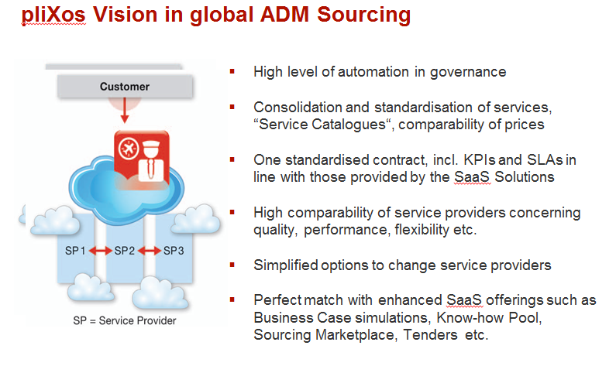

Picture 1: pliXos vision in global sourcing of application development & maintenance

**Risks**

In spite of many benefits, the number of organizations switching to Outsourcing in sum is still limited, exceptions being large and multinational corporates. Major reason for this low number of companies plunging into the pool of Outsourcing is that, SME’s still fear whether all the benefits claimed will be attained or not.

In this context the pliXos [B2B Marketplace](https://www.gsp-client.de/marketplace/register) takes a stand for the IT providers that either already demonstrated to successfully deliver to remote customers or were found to have the right ingredients for a success with clients interested in their help. So, these IT providers have an edge about the best practices in the industry and bring the desired output with reduced risk of taking any wrong decision by the customers.

Many customers think a lot, about have they chosen the right IT provider or not? Whether they will get the appropriate and timely services? pliXos has answers to these questions by its set of [SaaS](http://www.plixos.com/en/products) tools ranging from market analysis, sourcing strategy, supplier selection or an automated governance of projects.

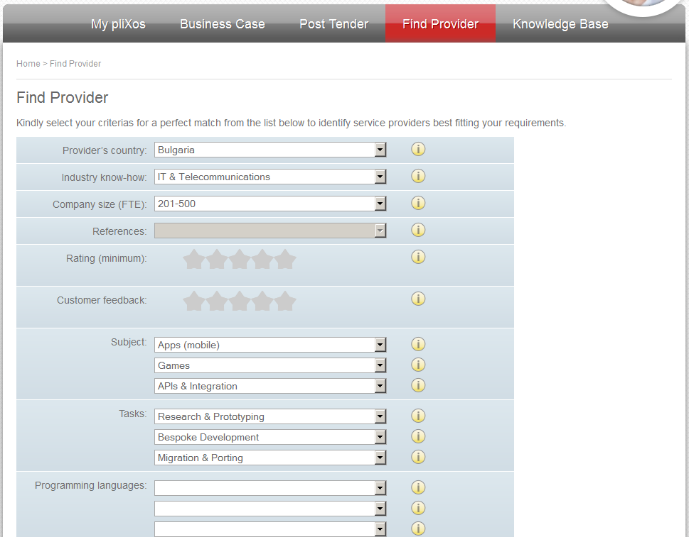

Picture 2: Simple but effective options to search for fitting service providers for customers within the pliXos [B2B Marketplace](https://www.gsp-client.de/marketplace/register)

Another risk that haunts an organization while planning to outsource is about the control of processes. Companies think that if an outside vendor is hired, there might be chances of a loss in supervision. pliXos answers this question by keeping control in the Outsourcing set up (of the providers delivery, any important aspects relevant for quality etc. ). It is the core of pliXos product [Outsourcing Director](http://www.plixos.com/en/products/outsourcing-director) (the KPI dashboard).

Sometimes it might happen that a company encounters a provider who does not keep documented all work on the system, even might have hidden charges. To avoid these circumstances pliXos provides the transparency of processes by properly owning the governance structure and having a tight control which allows overcoming a lock in any stage. On request, pliXos is also taking the [ownership of projects](http://www.plixos.com/en/it-outsourcing-services/general-contractor-for-projects) as a whole and ensures its success for the customer.

**Rewards**

The best advantage, as mentioned earlier is getting [expert’s advice](http://www.plixos.com/en/it-outsourcing-consulting). Yes, Outsourcing is one way to keep track of the changing technologies and have a global platform of the business. It is perhaps best to get connected with the knowledge and expertise of more than just one service providers.

IT vendors tend to hire staff with specific qualifications to maintain highly trained professionals so as to meet up the customer’s requirements. pliXos answers this question by our B2B [Marketplace](https://www.gsp-client.de/marketplace/register?0). It is the right place to search for high quality providers. Our [Provider Rating](http://www.plixos.com/en/plixos-blog-2/258-rating-of-software-services-%E2%80%93-benefit-from-our-work,-free-of-charge) based on scientific models is a great help for the customers. This also adds to our flexibility which we provide to the customers.

Comments or interested in digging deeper? Contact us directly [Aditya.Joshi@plixos.com](mailto:Aditya.Joshi@plixos.com) or [info@plixos.com](mailto:info@plixos.com). Or follow us [@pliXos_com](https://twitter.com/pliXos_com), [LinkedIn](https://www.linkedin.com/company/plixos-gmbh), [Facebook](https://www.facebook.com/pliXosGmbH/), [Google+](https://plus.google.com/118328872360908195110/about), [Youtube](https://www.youtube.com/channel/UCGdBxsUQF7sE1vPB5J0o_Wg), [Slideshare](http://de.slideshare.net/plixos/pli-xos-ovw).

***Sources :***

[“ 3 R’s of Outsourcing : Reasons, Risks and Rewards “ , Safar Safarov](https://www.linkedin.com/pulse/3-rs-outsourcing-reasons-risks-rewards-safar-safarov)

[“Service Integration in Nearshore Delivery How SMEs Can Benefit “, Tarun George and Joerg Stimmer](http://www.nearshoreamericas.com/services-integration-nearshore-delivery/)